P510/2
PHYSICS
Paper 2
July, 2017
2½ hours


ACEITEKA JOINT MOCK EXAMINATIONS 2017
UGANDA ADVANCED CERTIFICATE OF EDUCATION
PHYSICS
(Principal Subject)
PAPER 2
TIME: 2½ HOURS

INSTRUCTIONS TO CANDIDATES:
Answer only five questions, taking at least one question from each of the sections A, B, C and D, but not more than one question should be chosen from either section A or section B.
Any additional question(s) answered will not be marked.
Mathematical tables and squared paper will be provided.
Non-programmable Silent Scientific Calculators may be used.
Assume where necessary:
Acceleration due to gravity, g = 9.81m s ^{– 2}
Speed of light in Vacuum, c = 3.0 × 10⁸ m s ^{– 1}
Speed of sound in air, v = 3.40 × 10² m s ^{– 1}
Electronic charge, e = 1.60 × 10 ^{– 1 9}C
Electronic mass, m_{e} = 9.11 × 10 ^{– 31} kg
Permeability of free space, µ_{o} = 4π × 10 ^{– 7} H m ^{– 1}
Permittivity of free space, 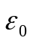 = 8.85 × 10 ^{– 1 2} F m ^{– 1}
The Constant, 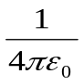 = 9.0 × 10 ⁹ F ^{– 1} m
SECTION A
1. (a) (i) In a plane mirror show that the reflected ray suffers a deviation of twice the glancing angle. (3 marks)
(ii) Two plane mirrors M₁ and M₂ are inclined at 65° to each other.
Incident ray OP is parallel to mirror M₂, but ray QR is not parallel to mirror M₁.
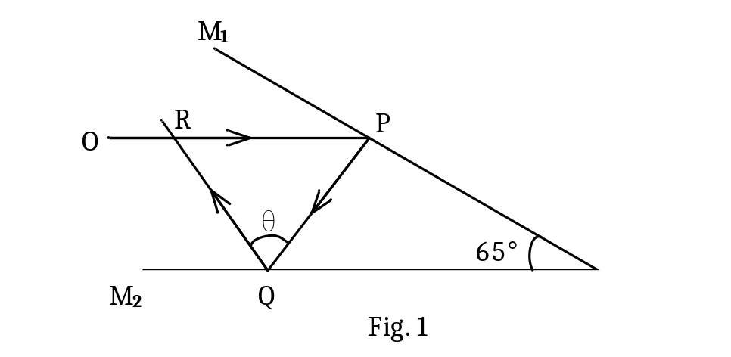
Determine the value of θ. (3 marks)
(b) Define the following terms as applied to concave mirrors.
(i) Radius of curvature. (1 mark) (ii) Aperture. (1 mark)
(c) A small quantity of liquid L₁ of refractive index 1.32 is poured into a concave mirror placed on a flat horizontal surface. An optical pin clamped horizontally above it coincides with its own image at 15.0cm above the mirror. When liquid 1 is replaced by liquid 2 and the procedure repeated, coincidence is established at a height h₂. If the ratio of the refractive index of liquid 1 to that of liquid 2 is 1.20. Determine;
(i) the position of coincidence between the pin and its image, when
liquid 2 is in the mirror. (3 marks)
(ii) refractive index of the liquid 2. (2 marks)

(d) A ray of monochromatic light is incident from air onto a pair of prisms placed in contact with each other at an angle i, as shown in figure 2. Prism A has refracting angle of 80° and refractive index 1.54 while prism B has refracting angle of 60° and refractive index 1.50. The light passes symmetrically through prism A.
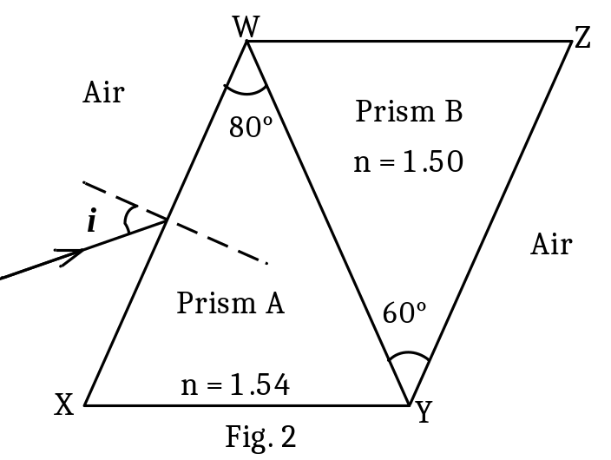
Find the:
(i) Value of angle, i. (2 marks)
(ii) total deviation suffered by the ray after emerging from prism B
into air. (5 marks)
2. (a) (i) Define the term focal length of a convex lens. (1 mark)
(ii) Describe an experiment to determine the focal length of a convex lens placed vertically inside an open ended tube. (5 marks)
(b) When the lens is placed in front of an illuminated object, image of height 18 cm is obtained on the screen. Keeping the object and screen fixed the lens is moved towards the screen until an image of height
8 cm was formed on the screen. Find the size of the object. (3 marks)

(c) (i) With the aim of a sketch ray diagram, derive an expression for the
angular magnification of the microscope, in terms of the focal lengths of the lenses used, with all terms in the expression well defined.
(4 marks)
(ii) A finite object is placed in front of a convex lens of focal length 3.0 cm
so as to form a final magnified virtual image at a distance of 25 cm from the eye piece of focal length 5.0 cm so that this image is in the plane of the object. Determine the separation of the lenses. (4 marks)

(d) Distinguish between a compound microscope and an astronomical telescope.
(3 marks)
SECTION B
3. (a) Distinguish between free and damped oscillations. (3 marks)
(b) (i) Define the terms harmonics and overtones. (2 marks)
(ii) A narrow tube of length 0.300 m is closed at one end. A tuning fork of frequency 825 Hz set into vibration just above the open end of the tube causes the air in the tube to resonate with the tuning fork. If the speed of sound in air is 330 ms ^{– 1,} determine the mode of vibration of air in the tube. (4 marks)
(c) (i) What is meant by the terms beats and Doppler effect? (3 marks)
(ii) A pedestrian moving in a straight line between two stationary sources of sound each of frequency 680 Hz, hears beats at a rate of 5.0 s ^{– 1}. Using well defined symbols, derive an expression for the speed of the pedestrian. Hence calculate the pedestrian’s speed. (5 marks)
(d) State three differences between sound waves and light waves. (3 marks)
4. (a) (i) Define the term interference of light waves. (1 mark)
(ii) Explain with the aid of a diagram how interference occurs in an
air-wedge. (3 marks)
(b) An air-wedge film formed by placing an aluminium foil between two glass slides at a distance of 75 mm from the line of contact of the slides. When the air wedge is illuminated normally, by light of wave length 5.60 × 10 ^{– 7} m, parallel interference fringes of separation 1.20 mm are produced.
Calculate the;
(i) angle between the slides. (2 marks)
(ii) thickness of the aluminium foil. (2 marks)
(c) (i) What is plane polarized light? (1 mark)
(ii) Describe with the aid of a labelled diagram, one application of
plane polarized light. (4 marks)
(d) (i) Describe an experiment to determine the wavelength of light waves
used in a diffraction grating. (5 marks)
(ii) A parallel beam of sodium light of wavelength 5.89 × 10 ^{– 7} m is incident normally on a diffraction grating having 6000 lines per cm. Find the angle for which the second order image will be seen. (2 marks)
SECTION C
5. (a) Define the following terms:
(i) Angle of declination. (1 mark)
(ii) Magnetic meridian. (1 mark)
(b) Describe an experiment to determine the horizontal component of the Earth’s magnetic field using a tangent galvanometer. (6 marks)
(c) (i) Define the term ampere and use this definition to show that the
permeability of free space µ₀ = 4π × 10 ^{– 7} H m ^{– 1} (3 marks)
(ii) The diagram in figure 3 shows three straight parallel wires P, Q and R of the same length L, carrying currents of 2A, 1A and 8A respectively. The distance between P and Q is x, while that between Q and R is d. The separation between wires P and R is 0.100 m.
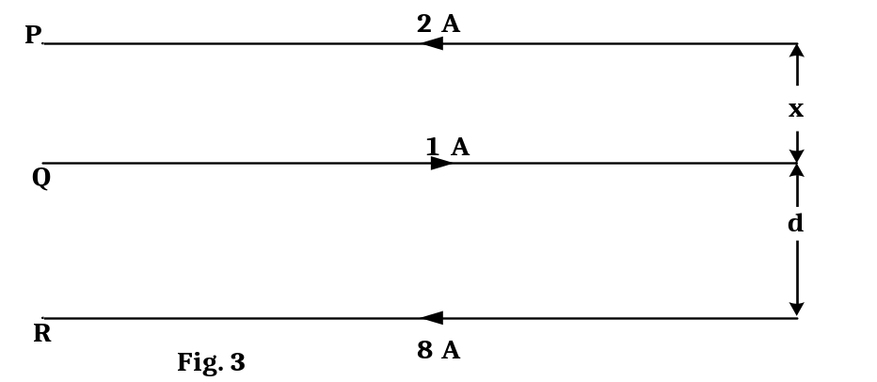
Find the value of d, for which the net force per metre on wire Q is zero.
(4 marks)
(d) Explain with the aid of a labelled diagram how a moving coil
loud speaker works. (5 marks)
6. (a) What is meant by the terms:
(i) Self induction? (1 mark)
(ii) Mutual induction? (2 marks)
(b) Figure 4 shows a strong bar magnet with ends S and N is attached to the free end of frictionless suspended helical spring from a fixed support. The magnet is displaced vertically downwards and left to perform vertical oscillations.
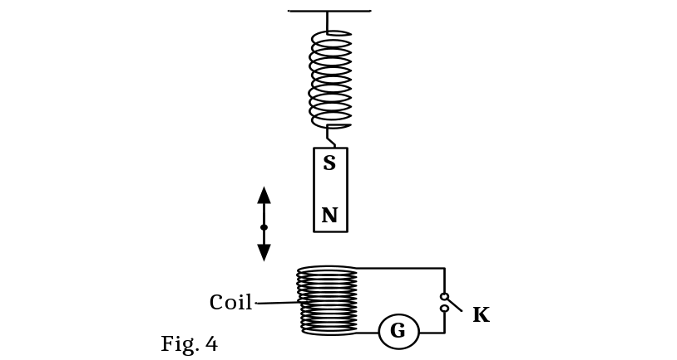
Explain the observations made when switch K is;
(i) open. (2 marks)
(ii) closed. (3 marks)
(c) A coil of 300 turns and with an area of 0.05 m² is rotated 20 times per second in a magnetic field of flux density 0.2 T. Calculate the;
(i) maximum e.m.f. produced across the ends of a coil. (3 marks)
(ii) torque required to maintain the rate of rotation if the current in the
coil is 0.8 A when the e.m.f. generated is a maximum. (2 marks)
(d) (i) Define the term self inductance of a coil. (1 mark)
(ii) The current in the coil rises from zero to 4.0 A in 1.5 s. If the inductance in the coil is 0.20 H. Calculate the magnitude of the e.m.f. induced in the coil. (3 marks)
(e) An air-cored inductor is connected in series with a switch and a d.c source. The switch is closed and left for some time. Explain why a spark is observed across the switch contacts when the switch is re-opened. (3 marks)
7. (a) (i) Define the terms amplitude and root mean square value of an alternating current. (2 marks)
(ii) Show that the r.m.s value of alternating current of amplitude I₀ is given by (3 marks)
(b) (i) Define the term inductive reactance. (1 mark)
(ii) Derive an expression for the inductive reactance of a pure inductor of self inductance L, connected to an alternating current, I = I₀ sin 2πft. (3 marks)
(c) A sinusoidal voltage of r.m.s value 10V is applied across a 50 µF capacitor.
(i) Find the maximum value of charge on the capacitor. (2 marks)
(ii) Draw a sketch graph of charge Q on the capacitor against
time and explain the features of the graph. (3 marks)
(d) (i) Define the term rectification. (1 mark)
(ii) Describe how full-wave rectification can be achieved using only two rectifiers. (5 marks)
SECTION D
8. (a) (i) Define the term volt. (1 mark)
(ii) Use the definition in (i) to derive an expression for power dissipated
in a resistor of resistance R ohms when a current I amperes flows through it. (3 marks)
(b) (i) Define electrical conductivity of a wire and state its unit. (2 marks)
(ii) Figure 5 shows current- voltage graphs for two Nichrome wires P and Q maintained at the same temperature.
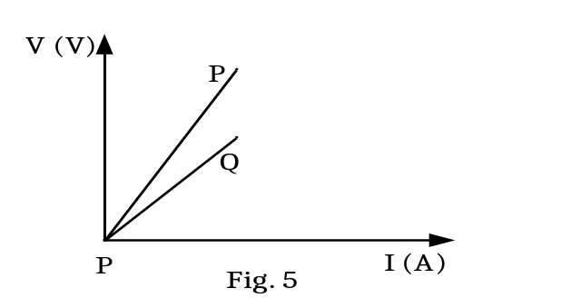
O
State and explain the difference in shapes of the two graphs. (4 marks)
(c) (i) Distinguish between Ohmic and non-Ohmic conductors. (2 marks)
(ii) Sketch current- voltage graphs of a silver wire and a junction diode, and briefly account for the shape of each graph. (4 marks)

(d) (i) Define temperature coefficient of resistance of a material. (1 mark) (ii) A heating coil made of Nichrome wire, having a temperature
coefficient of resistivity 8.0 × 10 ^{– 5} K ^{– 1} and resistivity of
1.08 × 10 ^{– 6} Ω m at 273 K, has a power rating of 36 W when immersed in water at 373 K at a p.d of 12 V. If the wire of the coil has a diameter of 0.36 mm, determine the length of wire used for making the coil. (4 marks)
9. (a) (i) Define the term electric field line. (1 mark)
(ii) Sketch electric field pattern due to an isolated positively charged metal sphere of radius r, placed in air. (2 marks)
(b) (i) What is meant by the term electric field intensity. (1 mark)
(ii) A neutral polythene ball of 120 mg is hanged at one end of a light uniform wooden beam at the 30.0 cm mark from the knife edge while a charged parallel plate air capacitor is at 20.0cm from the knife edge; as shown in figure 6.
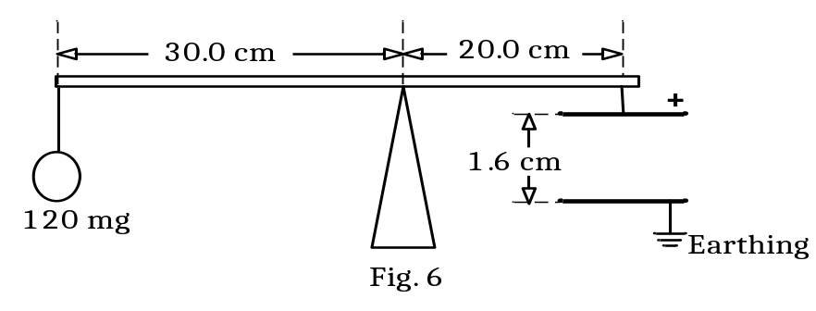
Given that, the charge on capacitor is 0.24 µC and the plates separation is 1.6 cm, determine the p.d. across the plates of the capacitor. (4 marks)
(c) (i) What is meant by the term corona discharge? (1 mark)
(ii) Explain why the metal caps of Gold leaf electroscopes are always
smooth and circular. (3 marks)
(d) (i) Describe an experiment to measure the dielectric constant of a
material placed between the plates of a parallel plate capacitor. (6 marks)
(ii) State two characteristics of a good dielectric material. (2 marks)
10. (a) (i) What is a capacitor? (1 mark)
(ii) Derive an expression for the effective capacitance of two capacitors arranged in series and connected to a d.c. supply. (4 marks)
(b) Explain the effect of a dielectric on the capacitance of a capacitor. (4 marks)
(c) The figure 7 shows 6 capacitors of capacitances 1.5μF, 2.5μF, 4.0μF, 5.0μF, 14.0μF and 28.0μF connected to a 12 V d.c. source.
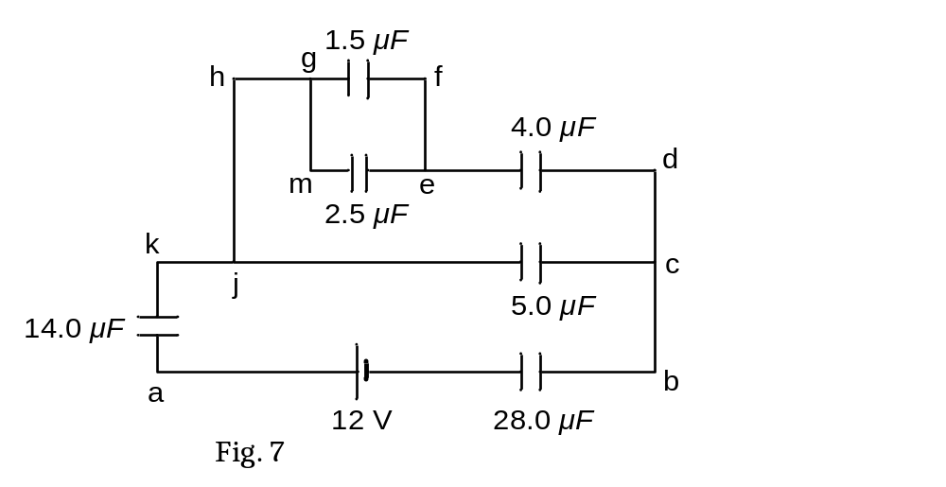
Determine;
(i) The effective capacitance of the network. (4 marks)
(ii) The energy stored in the 14μF capacitor. (3 marks)
(d) An electron is liberated from the lower of two large parallel metal plates separated by a distance of 2.0 cm. The upper plate has a potential of +2400 V with respect to the lower plate. Given that the charge to mass ratio of an electron is 1.76 × 10 ¹¹ C kg ^{– 1} , determine the time taken by the electron just
to reach the upper plate. (4 marks)

= END =

